The Pupil mapping Exoplanet Coronagraphic Observer

Olivier Guyonª, Stuart Shaklan^{b}, Marie Levine^{b}, Kerri Cahoy^{c}, Domenick Tenerelli^{d}, Ruslan Belikov^{c}, Brian Kern^{b}

ªSteward Observatory, University of Arizona, 933 Cherry Ave., Tucson, AZ 85721
^{b}NASA Jet Propulsion Laboratory, 4800 Oak Grove Drive, Pasadena, CA 91109
^{c}NASA Ames Research Center, Moffet Field, CA 94035, USA
^{d}Lockheed Martin Corporation, USA

ABSTRACT

The Pupil-mapping Exoplanet Coronagraphic Observer (PECO) mission concept is a 1.4-m space-based coronagraphic telescope optimized to image exoplanets and disks at optical wavelengths and characterize them through low resolution spectroscopy and polarimetry. Thanks to a high efficiency Phase-Induced Amplitude Apodization (PIAA) coronagraph, PECO can deliver 1e-10 contrast at 2 λ/D separation (0.15") with no loss in angular resolution or throughput due to the coronagraph. PECO acquires narrow field images simultaneously in 16 spectral bands over wavelengths from 0.4 to 0.9 μm , utilizing all available photons for maximum wavefront sensing efficiency and optimal sensitivity for imaging and spectroscopy. PECO can detect and characterize potentially habitable planets around 20 known F, G, K type stars, and map exozodiacal clouds to a fraction of our own own zodiacal dust content.
PECO's key technologies are currently under active development at several testbeds, and will enable efficient exoplanet imaging missions across a wide range of telescope sizes, from a sub-meter debris disk and giant planet imager to a ~4-m life-finding mission.
Keywords: Exoplanets, Coronagraphy

- PECO ARCHITECTURE: OVERVIEW

PECO's science goal is to directly image characterize exoplanetary systems around nearby stars. The most scientifically interesting PECO targets are also the most challenging: potentially habitable rocky planets orbiting nearby stars at approximately 1AU from their host stars. These planets are from 1 to 2 Earth radii, are approximately 10⁹ to 10¹⁰ times fainter that their host star, and, for a nearby system at a few parsec, have a maximum elongation of a few tenths of arcsecond. With a moderately-sized telescope like PECO, they are therefore extremely challenging due to both apparent brightness and small separation with the bright star. Detecting such planets with a 1.4-m telescope requires the instrument to simultaneously offer high end-to-end throughput, high contrast at a small inner working angle and a good angular resolution. These requirements have shaped the PECO architecture, which is shown in Figure 1. We describe in the next paragraph how PECO's architecture enables high efficiency observations. The other key requirements (contrast and inner working angle) are described in the PIAA coronagraph section.

PECO's high efficiency: coronagraph and wavelength splitting of light
High throughput is essential to reach the sensitivity required for detection of faint exoplanets, and is required to perform low resolution spectroscopy. It is also important for wavefront control, as the response time of the wavefront control loop is directly linked to the instrument's throughput. PECO's high end-to-end throughput, and more generally its high observing efficiency, is achieved by first adopting a lossless coronagraph technique able to preserve the sensitivity of the telescope. PECO uses a phase-induced amplitude apodization (PIAA) coronagraph (described in section 2), which performs beam apodization by reshaping instead of selective absorption. PECO also adopts a dichroic approach to multi-band imaging: light is split in wavelength bins by dichroics, so that PECO can simultaneously capture photon from 0.4 to 0.9 μm. Light is first split is four broad bands to feed four nearly identical coronagraph channels. Light is then split within each channel into four smaller wavelength bins. The first split is necessary for high contrast imaging, as the coronagraph and wavefront control hardware cannot easily maintain high contrast over a wide spectral band (for example, the coronagraph focal plane mask should ideally scale in diameter with wavelength). The second split is motivated by the need to spectrally characterize exoplanets and disks with 16 spectral bands.
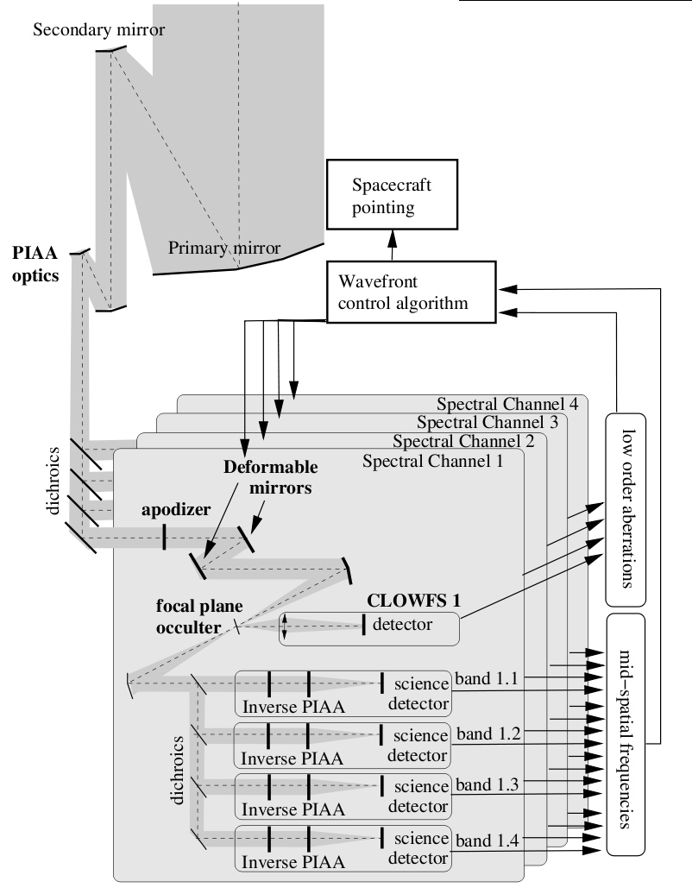
Figure 1: PECO architecture. The PECO off-axis telescope (top) feeds a coronagraph instrument composed of four nearly identical spectral channels for optimal use of incoming photons.

PECO's approach to multi-band imaging is made possible by the use of readnoise-free electron multiplying CCDs, which allow splitting of the light in several channels without compromising sensitivity.

- CORONAGRAPH

PECO uses a Phase-Induced Amplitude Apodization (PIAA) coronagraph to deliver high contrast images at small angular separation while maintaining the sensitivity and angular resolution of the telescope. A detailed description of this coronagraph technique can be found in previous publications^{1–8}, and we briefly summarize in this section its principle.

While conventional apodization relies on selective masking of pupil light to obtain an apodized beam, in a PIAA coronagraph, the telescope beam is apodized by two aspheric mirrors which reshape the telescope beam, as shown in figure 2. Two optical elements (mirrors in PECO) are required to perform the apodization: while a single aspheric mirror is sufficient to transform the top-hat illumination pattern of the telescope into a Gaussian-like profile, the second mirror is necessary to re-collimate the output beam. The edges of an apodization profile suitable for high contrast imaging are very dark, and it would be very challenging to manufacture PIAA M1 mirror to project such a dark edge on PIAA M2: the surface curvature at the outer edge of PIAA M1 would need to vary rapidly over a small distance. The apodization is therefore shared between the aspheric mirrors (which perform most of the apodization) and conventional apodizer(s) which can be located before or after the PIAA mirrors. In addition to making PIAA M1 manufacturable, sharing the apodization with a conventional apodizer also greatly improves the chromaticity of the PIAA coronagraph.

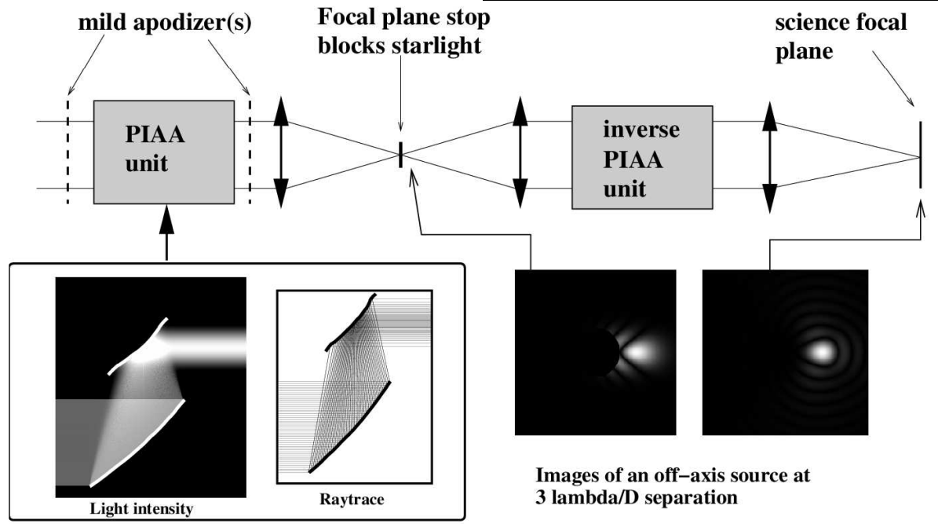
Figure 2: PIAA coronagraph architecture adopted for PECO. The PIAA unit (left) performs a lossless beam apodization, which yields a focal plane star image free of Airy rings. The focal plane mask removes starlight without attenuating the off-axis image of a planet. The inverse PIAA (right) is necessary to correct the strong off-axis aberration introduced by the PIAA.

With PIAA optics, strong apodizations can be achieved with no loss in throughput or angular resolution, enabling high contrast imaging at small angular separation from the optical axis with almost no loss in efficiency. The coronagraph inner working angle varies from 0.64 λ/D for an aggressive PIAA design using a phase-shifting focal plane mask to 2 λ/D for a more conventional PIAA design (adopted for PECO). The design choice depends on the goal contrast, ability to mitigate chromatic issues and angular size of the central source. PIAA does not absorb light, and it therefore preserves the sensitivity and angular resolution of the telescope. When using mirrors, PIAA can be made to operate at high contrast over a wide spectral band. The beam shaping performed by the PIAA optics introduces strong off-axis aberrations which limit the useful field of view to about 8 λ/D. The PIAAC architecture adopted for PECO, shown in Figure 2 therefore includes an inverse PIAA to recover a wider unaberrated field of view in the science focal plane.

- WAVEFRONT CONTROL ARCHITECTURE

PECO's wavefront control architecture is shown in figure 3. In each of the four spectral channels, a pair of deformable mirrors (DMs) is used to correct the wavefront to the 1e-10 contrast level. The wavefront control system is highly integrated with the coronagraph architecture.

Mid-spatial frequencies responsible for scattered light in the 2 to 15 λ/d range are sensed by using the DMs as probes: the DMs are used to create known speckles which interfere with the unwanted scattered light in the focal plane. The measured intensities in the focal plane image reveal the complex amplitude and coherence of the speckles. The coherent portion of the speckles is then canceled by adding speckles with the opposite complex amplitude. This scheme is now used on several testbeds and is described in previous publications^{10,11}.

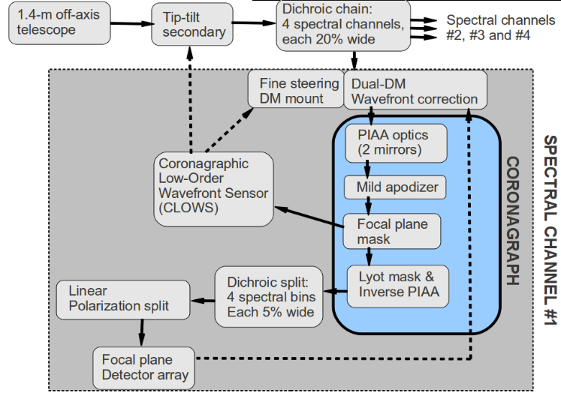
Figure 3: Overview of the wavefront control architecture for PECO. In each spectral channel, a pair of deformable mirrors (DMs) is used for polychromatic wavefront correction.

High contrast imaging at small inner working angle requires exquisite knowledge and control of low-order aberrations (tip-tilt and Focus). PECO uses a dedicated low order wavefront sensor^{12,13} to measure these aberrations. The sensor collects starlight reflected by the focal plane mask, which allows accurate and fast measurement of aberrations which, if uncontrolled, would create light leaks around the coronagraph focal plane mask.

- EXPECTED SCIENCE PERFORMANCE

5.1 Exoplanets
A detailed numerical model of the coronagraph was created to estimate PECO's ability to detect exoplanets. The model accurately simulates the coronagraph response (including coronagraphic leaks due to the angular size of the star), photon noise from starlight, the planet image, zodiacal and exozodiacal light. The model assumes perfect wavefront correction, and is therefore only valid if speckles can be reduced below the zodiacal background (between 10⁻⁹ and 10⁻¹⁰ contrast).

Results are compiled in table 1, which gives the number of stars around which exoplanets of different types would be detected by PECO within a one day exposure. For about 50 FGK main sequence stars, PECO could detect a large rocky planet at the outer edge of the habitable zone. PECO could detect an Earth analog around 20 stars. For most planet within the habitable zone, detection and spectral characterization are limited to the blue part of PECO’s spectral coverage where the IWA and angular resolution are more favorable. PECO’s observing strategy is to devote most of the mission duration to the observation of the ≈20 easiest stars for which exoplanets could be imaged within the habitable zone. For this deep survey, planets will be most efficiently identified by PECO’s blue spectral channels (better IWA) with several (10 or more) independent observations of the same target star.

Table 1. Number of FGK main sequence stars around which different planet types can be detected (SNR=5 at R=5 at 0.55 μm) with an ideal (perfect wavefront) PECO-sized (1.4-m) PIAA telescope, and with a smaller (1.0-m) and larger (1.8-m) PIAA telescope. Details of this simulation can be found in Guyon et al. 2006. This table assumes a 1 zodi cloud around each star and a 50% throughput loss due to coatings and detector. The numbers given are for 20% detection probability for a single 1 day exposure with no prior information on the planet location, corresponding to 90% probability of at least one detection in 10 uncorrelated visits. Super Earths are assumed here to have 2x Earth radius. The HZ unit denotes the distance at which an Earth-like planet would have the same temperature as the Earth.
 | Earth  at 1 HZ  albedo = 0.3 | SuperEarth  at 1 HZ  albedo = 0.3 | SuperEarth  at 1.8 HZ  albedo = 0.3 | Jupiter  at 1 AU  albedo = 0.6 | Jupiter  at 5 AU  albedo = 0.6
1.0-m PIAA | 5 | 13 | 23 | 21 | 437
PECO (1.4-m) | 20 | 38 | 56 | 52 | 1179
1.8-m PIAA | 41 | 79 | 127 | 103 | 2545

Following their identification, PECO will perform higher SNR observation of the few most promising targets: Earth or Super-Earth exoplanets which have been identified in PECO’s deep survey and/or have been known from other observations (for example ground-based radial velocity or space-based astrometry). For these few targets, PECO could accumulate up to several weeks of exposure time, scheduled when the planet separation is maximum to allow spectral characterization into the red end of PECO’s spectral range. For example, an Earth in the HZ of eps Eri would be imaged at 550 nm at R=5, SNR=20 in 24 hr exposure in the presence of 1 zodi of exozodiacal dust.

Jupiter-like planets can be imaged by PECO around a significantly larger number of stars, and will be probed in both the deep survey and a larger but shallower survey of 150 additional targets. Many of the giant planets PECO will observe are already or will soon be known by ground-based radial velocity surveys. PECO can detect at least 12 of the known RV planets. For example, 47 Uma b would be detected in the 500 nm to 600 nm spectral range in just a few hours in the presence of 3 zodi of exozodi. PECO will acquire a statistically meaningful set of low resolution spectra for gas giants from Neptune mass to several times Jupiter mass.

5.2 Circumstellar disks
PECO will also map with unprecedented sensitivity exozodial disks with 1λ/D spatial resolution. Around the 20 deep survey targets, PECO will have the sensitivity to image exozodiacal fainter than our own. Simultaneous observation of planets and exozodiacal dust in many systems will greatly enhance our understanding of planetary systems architectures and evolution. The PECO debris disk and dust science objectives are:
1. Obtain a census of scattered light images of debris disks to the level of our own solar system and from habitable zones outwards
2. Observe the dynamical structures in disks to learn about the distribution of dust and any unseen planets
3. Characterize the physical properties of the debris dust in exoplanetary systems.

- PIAA TECHNOLOGY DEVELOPMENT

The PIAA coronagraph system (PIAA optics + wavefront correction) at the core of PECO's instrument design has been implemented in four laboratory testbeds and instruments, shown in figure 4:
- The first prototype PIAA system was assembled at the Subaru Telescope laboratory. This testbed, now discontinued, reached 2e-7 contrast at 2 λ/D with a reflective set of PIAA mirrors in air¹¹. The contrast performance was limited by ghosts created by refractive relay optics.
- A PIAA coronagraph is part of the Subaru Coronagraphic Extreme-AO (SCExAO) system¹⁴, which is scheduled to see first light on the Subaru Telescope in early 2011. This lens-based PIAA system is designed to deliver up to 1e-6 contrast at 1 λ/D , and will be limited by residual atmospheric turbulence. It will provide valuable experience for wavefront control with a PIAA coronagraph.
- NASA Ames operates a PIAA system laboratory testbed in air. The testbed is currently achieving 5e-8 contrast in monochromatic light in a 2 to 5 λ/D separation range from the central star¹⁵. The testbed currently uses refractive optics, and will later be upgraded to refractive optics for polychromatic light. The Ames testbed is highly flexible, and is optimized for rapid development and testing of new techniques and wavefront algorithms related to PIAA coronagraphy.
- The High Contrast Imaging Testbed (HCIT) at NASA JPL is currently testing a PIAA coronagraph system. With a highly stable vacuum environment, the HCIT testbed will be the only testbed able to test PIAA at and beyond 1e-9 contrast.
The NASA Ames and NASA JPL testbed are coordinating efforts to validate PIAA technology: new techniques, components and algorithms are best tested at NASA Ames up to approximately 1e-8 contrast, while high contrast (beyond 1e-9) work requires the stability of the HCIT vacuum tank.

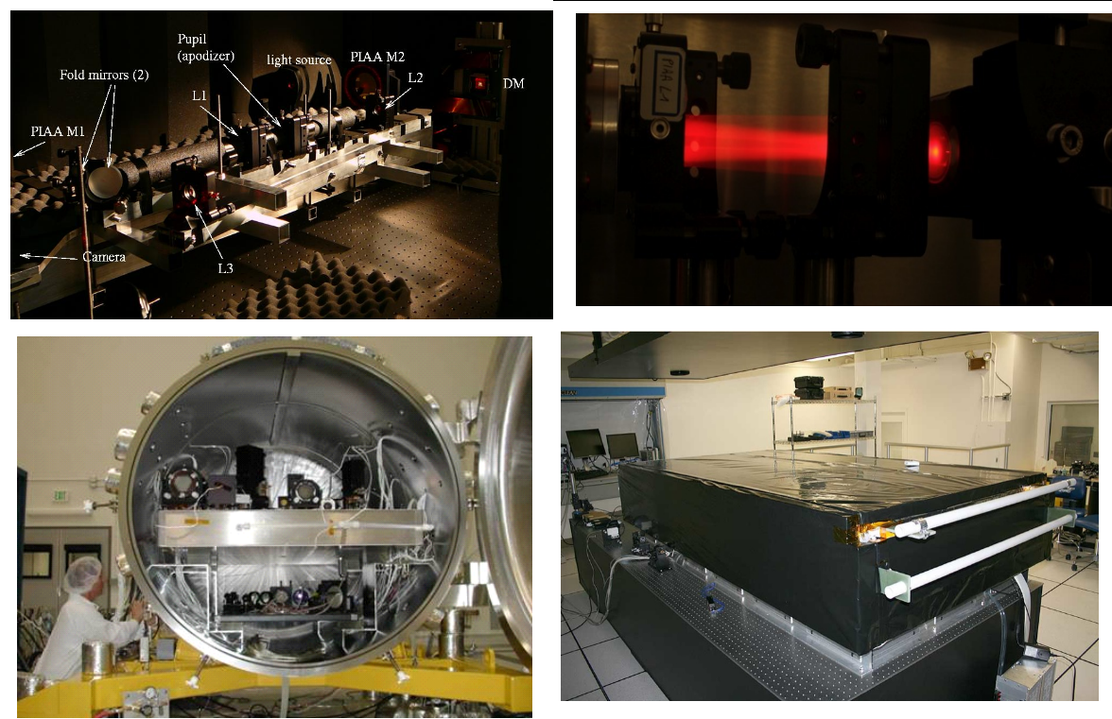
Figure 4: PIAA coronagraph testbeds and systems: Subaru Telescope PIAA laboratory testbed (top left), refractive PIAA unit inside the Subaru Coronagraphic Extreme-AO system, scheduled to see first light in early 2011 (top right), PIAA table inside the High Contrast Imaging Testbed at NASA JPL (bottom left), and PIAA laboratory testbed at NASA Ames (bottom right).

- CONCLUSIONS, FUTURE WORK

The PECO mission concept study has shown that, thanks to the use of a PIAA coroagraph with small IWA and high efficiency, a 1.4-m telescope can image the habitable zones of nearby stars with sufficient sensitivity to acquire, on the most favorable targets, low resolution spectra of Earth-sized planets and, for a few tens of stars, map exozodiacal clouds down to sub-zodi levels. Such observations are however challenging, and the required level of wavefront control and calibration has yet to be demonstrated with a PIAA coronagraph. Laboratory validation of the PECO instrument concept at the required contrast level is ongoing, with testbeds at NASA Ames and NASA JPL.

Several possible improvements/enhancements to the baseline PECO mission are currently under study, most notably (1) a higher performance PIAA-based coronagraph with improved IWA and (2) an astrometry mode¹⁶ which would enhance PECO's ability to detect exoplanets and allow direct measurement of their masses. The technologies baselined for the PECO concept are directly applicable to smaller and larger telescope sizes. A 4-m telescope using PECO's coronagraph architecture would be able to identify biomarkers on nearby habitable planets, while a 0.5-m telescope could map exozodiacal disks of our closest neighbors and image a few giant planets in the visible.

REFERENCES
[1] Guyon, O. "Phase-induced amplitude apodization of telescope pupils for extrasolar terrestrial planet imaging", A&A, 404, 379 (2003)
[2] Traub, W.A., Vanderbei, R.J., "Two-Mirror Apodization for High-Contrast Imaging", ApJ, 599, 695 (2003)
[3] Guyon, O., Pluzhnik, E.A., Galicher, R., Martinache, F., Ridgway, S.T., Woodruff, R.A. "Exoplanet Imaging with a Phase-induced Amplitude Apodization Coronagraph. I. Principle", ApJ, 622, 744 (2005)
[4] Vanderbei, R.J., Traub, W.A. "Pupil Mapping in Two Dimensions for High-Contrast Imaging", ApJ, 626, 1079 (2005)
[5] Martinache, F., Guyon, O., Pluzhnik, E.A., Galicher, R., Ridgway, S.T. "Exoplanet Imaging with a Phase-induced Amplitude Apodization Coronograph. II. Performance", ApJ, 639, 1129 (2006)
[6] Vanderbei, R.J. "Diffraction Analysis of Two-dimensional Pupil Mapping for High-Contrast Imaging", ApJ, 636, 528 (2006)
[7] Pluzhnik, E.A., Guyon, O., Ridgway, S.T., Martinache, F., Woodruff, R.A., Blain, C., Galicher, R. "Exoplanet Imaging with a Phase-induced Amplitude Apodization Coronagraph. III. Diffraction Effects and Coronagraph Design", ApJ, 644, 1246 (2006)
[8] Pluzhnik, E.A., Guyon, O., Warren, M., Woodruff, R.A., Ridgway, S.T., “PIAA coronagraph design: system optimization and first optics testing”, SPIE, 6265-135 (2006)
[9] Guyon, O., Pluzhnik, E. A., Kuchner, M. J., Collins, B., Ridgway, S. T. "Theoretical Limits on Extrasolar Terrestrial Planet Detection with Coronagraphs", ApJS, 167, 81 (2006)
[10] Give’on, A., Kern, B., Shaklan, S., Moody, D.C., Pueyo, L. "Broadband wavefront correction algorithm for high-contrast imaging systems", SPIE, 6691 (2007)
[11] Guyon, O., Pluzhnik, E.A., Martinache, F., Totems, J., Tanaka, S., Matsuo, T., Blain, C., Belikov, R. "High Contrast Imaging and Wavefront Control with a PIAA Coronagraph: Laboratory System Validation", PASP, Volume 122, pp.71-84 (2010)
[12] Guyon, O., Matsuo, T., Angel, R., "Coronagraphic Low Order Wavefront Sensor: Principle and Application to a Phase-Induced Amplitude Coronagraph" ApJ, 693, pp 75-84 (2009)
[13] Vogt, F., Guyon, O., Martinache, F., Garrel, V., Yokochi, K., Yoshikawa, T., Matsuo, T. “The Subaru coronographic extreme adaptive optic (SCExAO) system: implementation and performance of the coronographic low-order wave-front sensor”, SPIE, 7736-37 (2010)
[14] Martinache, F., Guyon, O., Vogt, F., Garrel, V., Yokochi, K., Yoshikawa, T., “The Subaru coronagraphic extreme AO (SCExAO) system: progress report”, SPIE, 7736-216 (2010)
[15] Belikov, R., Pluzhnik, E.A., Connelley, M.S., Witteborn, F.C., Greene, T.P., Lynch, D.H., Zell, P.T., Guyon, O. “Laboratory demonstration of high-contrast imaging at 2 l/D enabled by temperature stabilization of the testbed”, SPIE, 7731-84 (2010)
[16] Guyon, O., Shao, M., Shaklan, S., Levine, M., Ammons, M., Bendek, E., Woodruff, R.A., Nemati, B., Pitman, J. “Single aperture imaging astrometry with a diffracting pupil: application to exoplanet mass measurement with a small coronagraphic space telescope”, SPIE, 7731-83 (2010)

